**Kubernetes Setup Using Kubeadm In AWS EC2 Ubuntu Servers - Mithun Technologies - +91-9980923226**

**Mithun Technologies            +91-9980923226              devopstrainingblr@gmail.com**

<http://mithuntechnologies.com/>  
                                                       <http://mithuntechnologies.co.in/>  
  
**Agenda: Kubernetes Setup Using Kubeadm In AWS EC2 Ubuntu Servers  
=======================================================**  
  
**Prerequisite:  
==========**  
  
3 - Ubuntu Serves  
  
1 - Manager  (4GB RAM , 2 Core) t2.medium  
  
2 - Workers  (1 GB, 1 Core)     t2.micro  
  
  
**Note:**Open Required Ports In AWS Security Groups. For now we will open All trafic.  
  
==========COMMON FOR MASTER & SLAVES START ====  
  
# First, login as ‘root’ user because the following set of commands need to be executed with ‘sudo’ permissions.  
  
sudo su -  
  
# Install Required packages and apt keys.  
  
apt-get update -y  
apt-get install -y apt-transport-https  
curl -s https://packages.cloud.google.com/apt/doc/apt-key.gpg | apt-key add -  
cat <<EOF >/etc/apt/sources.list.d/kubernetes.list  
deb https://apt.kubernetes.io/ kubernetes-xenial main  
EOF  
apt-get update -y  
  
  
  
#Turn Off Swap Space  
  
swapoff -a  
sed -i '/ swap / s/^\(.*\)$/#\1/g' /etc/fstab  
  
# Install And Enable Docker  
  
apt install docker.io -y  
usermod -aG docker ubuntu  
systemctl restart docker  
systemctl enable docker.service  
  
  
#Install kubeadm, Kubelet And Kubectl  
  
apt-get install -y kubelet kubeadm kubectl kubernetes-cni  
  
# Enable and start kubelet service  
  
systemctl daemon-reload  
systemctl start kubelet  
systemctl enable kubelet.service  
  
==========COMMON FOR MASTER & SLAVES END=====  
  
  
  
===========In Master Node Start====================  
# Steps Only For Kubernetes Master  
  
# Switch to the root user.  
  
sudo su -  
  
# Initialize Kubernates master by executing below commond.  
  
kubeadm init  
  
#exit root user & exeucte as normal user  
  
exit  
  
mkdir -p $HOME/.kube  
sudo cp -i /etc/kubernetes/admin.conf $HOME/.kube/config  
sudo chown $(id -u):$(id -g) $HOME/.kube/config  
  
  
# To verify, if kubectl is working or not, run the following command.  
  
kubectl get pods -o wide --all-namespaces  
  
#You will notice from the previous command, that all the pods are running except one: ‘kube-dns’. For resolving this we will install a # pod network. To install the weave pod network, run the following command:  
  
kubectl apply -f "https://cloud.weave.works/k8s/net?k8s-version=$(kubectl version | base64 | tr -d '\n')"  
  
kubectl get nodes  
  
kubectl get pods --all-namespaces  
  
  
# Get token  
  
kubeadm token create --print-join-command  
  
=========In Master Node End====================  
  
  
Add Worker Machines to Kubernates Master  
=========================================  
  
Copy kubeadm join token from and execute in Worker Nodes to join to cluster  
  
  
  
kubectl commonds has to be executed in master machine.  
  
Check Nodes  
=============  
  
kubectl get nodes  
  
  
Deploy Sample Application  
==========================  
  
kubectl run nginx-demo --image=nginx --port=80  
  
kubectl expose deployment nginx-demo --port=80 --type=NodePort  
  
  
Get Node Port details  
=====================  
kubectl get services

**Convert pem(Privacy-Enhanced Mail) file to ppk(PuTTY Private Key) file - Mithun Technologies +91-9980923226**

**Mithun Technologies            +91-9980923226              devopstrainingblr@gmail.com**                                                       <http://mithuntechnologies.com/>  
                                                       <http://mithuntechnologies.co.in/>  
**Step1) To convert .pem file to .ppk , we need to use the puttygen software.  
Download the puttygen(for 64 bit Windows OS) software by using below url.**  
[**https://the.earth.li/~sgtatham/putty/latest/w64/puttygen.exe**](https://the.earth.li/~sgtatham/putty/latest/w64/puttygen.exe)

[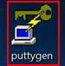](https://1.bp.blogspot.com/-xIPcEIdhbvI/XXpUNrnn2-I/AAAAAAAAAqw/wxOHtszj6xYJeoJA1Slj7kSJ57OZAKp2QCPcBGAYYCw/s1600/1.jpg)

**Step2) Open the puttygen software.**

Click on puttygen.exe icon.

[](https://1.bp.blogspot.com/-xIPcEIdhbvI/XXpUNrnn2-I/AAAAAAAAAqw/wxOHtszj6xYJeoJA1Slj7kSJ57OZAKp2QCPcBGAYYCw/s1600/1.jpg)

Once you have double clicked on puttygen.exe file, it will open the below screenshot.

[[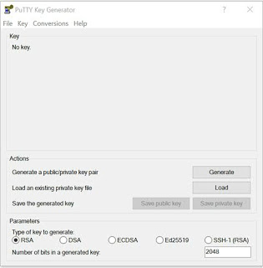](https://1.bp.blogspot.com/-rqbiW4-ugYQ/XXpUh8p-bHI/AAAAAAAAAq8/E5m7vgq0phAVbNrVR5UAYEuDpG4z-XgQACPcBGAYYCw/s1600/2.jpg)](https://1.bp.blogspot.com/-rqbiW4-ugYQ/XXpUh8p-bHI/AAAAAAAAAq8/E5m7vgq0phAVbNrVR5UAYEuDpG4z-XgQACPcBGAYYCw/s1600/2.jpg)

**Step3) Load the pem file as follows.**

Click on Load button and select the pem file and click on Open, as follows.

[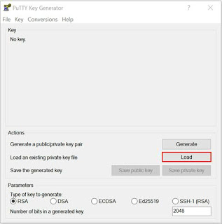](https://1.bp.blogspot.com/-eXJ5z9Fs3AM/XXpUxBwMviI/AAAAAAAAArE/JNh6q-_mBsExdM_xJcdBaNl67FdUWicuwCPcBGAYYCw/s1600/3.jpg)

[[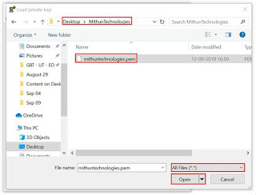](https://1.bp.blogspot.com/-jxKzzSWcb4c/XXpU-jSI3oI/AAAAAAAAArM/U1s0jpr0oHselxYJfHMNeB6l71KGR4F2wCPcBGAYYCw/s1600/4.jpg)](https://1.bp.blogspot.com/-jxKzzSWcb4c/XXpU-jSI3oI/AAAAAAAAArM/U1s0jpr0oHselxYJfHMNeB6l71KGR4F2wCPcBGAYYCw/s1600/4.jpg)

Once you have clicked on Open, you will see below popup, click on OK button.

[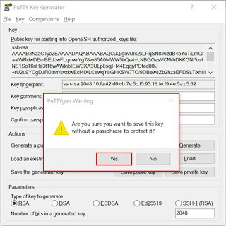](https://1.bp.blogspot.com/-1nf9a9z-RcI/XXpVJ9imiKI/AAAAAAAAArY/V24GTqwK7Akz1-8zXSfuOXh_vna_xE9DwCPcBGAYYCw/s1600/5.jpg)

**Step4) Save the ppk file.**

Click on Save private key button and select the path to store the ppk file as follows.

[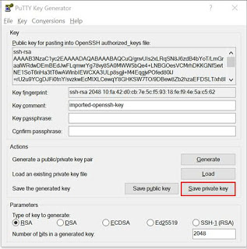](https://1.bp.blogspot.com/-HkbOKIXOCw4/XXpVYeV_O-I/AAAAAAAAArY/acAN61Qm8mkoe4wNK5pvHdwApn0cJ_PuQCPcBGAYYCw/s1600/6.jpg)

Give the filename for ppk file and click on Save button as follows.

[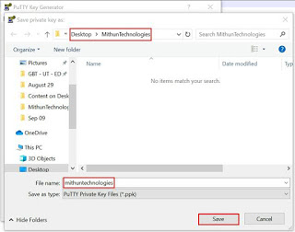](https://1.bp.blogspot.com/-rYc0BxQ3m7U/XXpViVUquvI/AAAAAAAAArg/uDVe6OSsClU3J2wrD8U0PPQl1qCl_JK_wCPcBGAYYCw/s1600/7.jpg)

Click on close symbol, once you have successfully generated.

[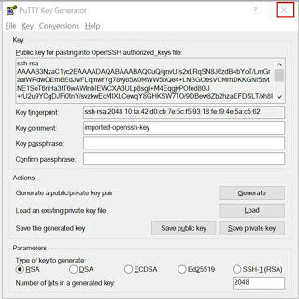](https://1.bp.blogspot.com/-qEx5ah6h7i8/XXpVwAwlXxI/AAAAAAAAAro/y2IzZqzKELItPJ7OvVyJXf8o7zssvljrgCPcBGAYYCw/s1600/8.jpg)

**Step5) Login into AWS EC2 instance  using ppk file as follows.**

Download the putty software (for 64 bit Windows OS) from below url if you don’t have downloaded already from below url.

[**https://the.earth.li/~sgtatham/putty/latest/w64/putty.exe**](https://the.earth.li/~sgtatham/putty/latest/w64/putty.exe)

Once you have downloaded the putty software copy the putty software executable file (putty.exe) from Downloads folder to Desktop.

Open the Putty software. (Double click on putty.exe file), as follows.

[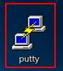](https://1.bp.blogspot.com/-sKmahgzTw0Q/XXpV_u2IRmI/AAAAAAAAArw/zch2Spit2BI0g1U4a8ajwN84yVULQVT8wCPcBGAYYCw/s1600/9.jpg)

Give the IP address of which server you want to connect as follows.

[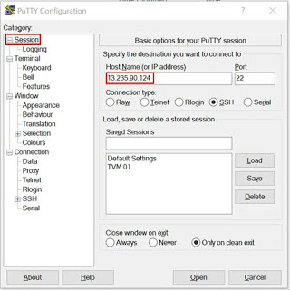](https://1.bp.blogspot.com/-7lyMzMyi2hY/XXpWLelSQ-I/AAAAAAAAAr0/95t11vjxmYIhqqjhi9XKqBPSpdnFEdaCgCPcBGAYYCw/s1600/10.jpg)

**Select the ppk file**

Expand on SSH --> Expand Auth --> Click on Browse and select the ppk file and click on Open button as follows.

[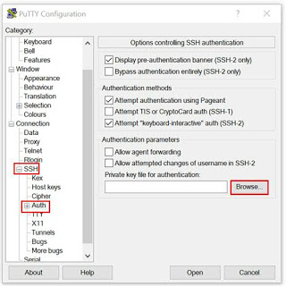](https://1.bp.blogspot.com/-gG26D4AZsuM/XXpWdcHLZWI/AAAAAAAAAr8/Jl-NnMLpWYMZvrZFiKf9KA3Xz6eWwjAoACPcBGAYYCw/s1600/11.jpg)

[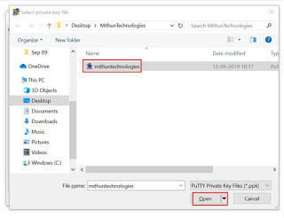](https://1.bp.blogspot.com/-mEMMeZcIy4I/XXpWwAhF48I/AAAAAAAAAsQ/5JcZtH75By0BVXbQqpd8eVFSCWMaiuxcQCPcBGAYYCw/s1600/12.jpg)

[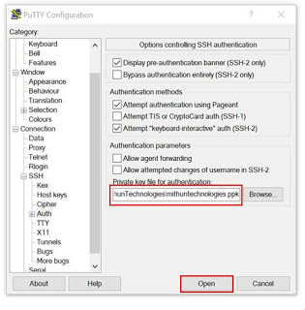](https://1.bp.blogspot.com/-yi5d7xFWkF0/XXpW9gXepVI/AAAAAAAAAsQ/KJyspGf81a4g30MapfTR8O9ScWRReBc4wCPcBGAYYCw/s1600/13.jpg)

Give the username as **ec2-user** for RHEL instance and hit the **Enter**button.

[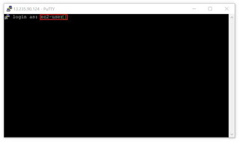](https://1.bp.blogspot.com/-ZCMqxHAwH5g/XXpXDevbVuI/AAAAAAAAAsY/Mb1QfechmA8FtLw0UokiZcFlUe1rlDS6wCPcBGAYYCw/s1600/14.jpg)

[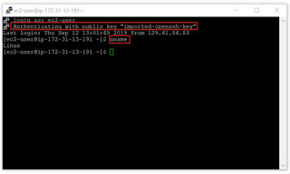](https://1.bp.blogspot.com/-I5bmqDtStRM/XXpXRV8LY0I/AAAAAAAAAsc/DbtvA0ieGBAnldSIX5grme5M8IT-ubJqQCPcBGAYYCw/s1600/15.jpg)

Type **exit** command for disconnecting.